HACKATEERS

GROUP-5

COOK BOOK(PS-2)

FRONT END:

OUTPUT:

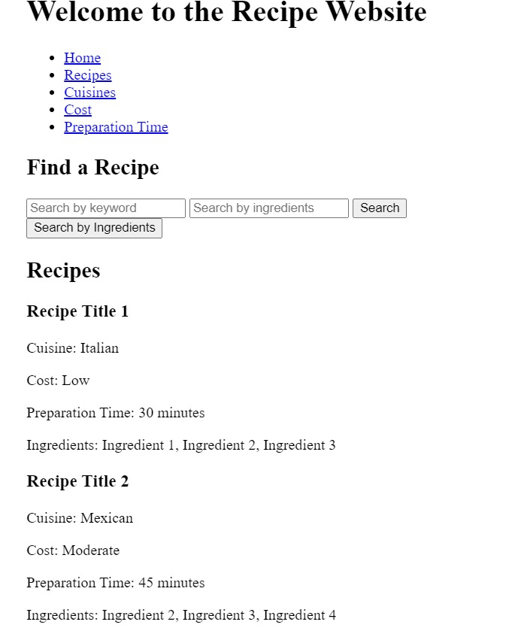

BACK END:

OUTPUT:

